1. **GENERAL REQUIREMENTS**

**1.1.** The reference list must include at least 8 sources, with a minimum of 30% consisting of foreign publications from the last 5 years. References to articles published in the Arts Academy journal are encouraged.

**1.2.** Citation, referencing, and bibliography formatting must comply with **Chicago 17th Edition (Author-Date).**

**1.3.** For articles written in Kazakh and Russian, two reference sections must be prepared: **Пайдаланылған әдебиеттер тізімі / Список использованных источников** – in the original language, listed in alphabetical order using Cyrillic script; and References – a duplicate list in Latin script. The order should be: **Cyrillic → Latin.**

**1.4.** For articles in English, **only the References** section is required.

**1.5.** If the cited article has a DOI, it must be included.

**1.6.** An active link to an online source (a full URL starting with http://) and the access date must be provided.

**1.7.** All **technical terms** in bibliographic descriptions must be given in English (e.g., editor, ed., p., Vol., etc.).

**2. IN-TEXT CITATION**

2.1. In-text citations follow the “**author-year, page**” format (author’s last name, year, page number): *(Utgalieva 2021, 188).*

2.2. If a source has more than three authors, list **the first two authors'** last names followed by *et al.*: *(Mukhametova, Amanov et al. 2002, 168–171).*

2.3. If multiple sources by the same author exist, distinguish them by **publication year**: *(Mukhametova 1976), (Mukhametova 2002).* **If citing multiple works by the same author**, separate them with a comma: *(Mukhametova 1976, 2002).*

2.4. If citing works by the same author with different co-authors, use the following format: *Gofman and Petrov 1961; Gofman, Ivanov, and Sidorov 1974.*

1. **REFERENCES FORMATTING**

The reference list should be arranged in alphabetical order.  
Sources written in Cyrillic script should be placed first, followed by Latin-script sources. The year of publication should be written in bold.

**JOURNALS**

Journal articles are usually cited by volume and issue number. In the reference list, include the page range for the whole article. In the text, cite specific page numbers. For articles consulted online, include a **URL (based on a DOI)** in the reference list entry; alternatively, list the name of the database.

***Reference list entries (in alphabetical order)***

Last Name, First Initial(s). Year. “Title of the Article.” *Title of the Journal* Volume (Issue): Page range. DOI or URL.

Bulankina, M.K. 2024. “Current Issues in Improving Pedagogical Skills in the System of Choreographic Education.” *Arts Academy: Scientific Journal* 4 (12): 14–29. <https://doi.org/10.56032/2523-4684.2024.4.12.14>.

Yesirkepova, Sh.T. 2024. “Psychological Preparation of a Student for Stage Performance on the Piano.” *Arts Academy: Scientific Journal* 4 (12): 44–51. <https://doi.org/10.56032/2523-4684.2024.4.12.44>.

Dittmar, Emily L., and Douglas W. Schemske. 2023. “Temporal Variation in Selection Influences Microgeographic Local Adaptation.” *American Naturalist* 202 (4): 471–85. https://doi.org/10.1086/725865.

Hebert, B. T. 1925. “The Island of Bolsö: A Study of Norwegian Life.” *Sociological Review* 17 (4): 307–13. EBSCOhost.

***In-text citations***

(Bulankina 2024, 17)

(Yesirkepovа 2024, 48)

(Dittmar and Schemske 2023, 480)

(Hebert 1925, 310)

In the **Chicago Author-Date** style, authors’ names in the reference list are given in the form in which they appear in the original publication or in an authoritative database (such as CrossRef, Scopus, or Web of Science). Therefore, in some examples, the full name is provided (e.g., *Emily L. Dittmar*), while in others only initials are used (e.g*., B.T. Hebert*).

For works by **two authors**, list both in the reference list and the text (as in the Dittmar and Schemske example above). For **three or more** authors, list up to six in the reference list; for **more than six** authors, list the first three, followed by “et al.” (“and others”). In the text, list **only the first**, followed by “et al.”

***Reference list entry***

Dror, Amiel A., Nicole Morozov, Amani Daoud, et al. 2022. “Pre-Infection 25-Hydroxyvitamin D3 Levels and Association with Severity of COVID-19 Illness.” *PLOS ONE* 17 (2): e0263069. https://doi.org/10.1371/journal.pone.0263069.

***In-text citation***

(Dror et al. 2022, 10–11)

**COLLECTIONS**

Abusaitova, M.Kh. 2021. History of Central Asia: Concepts, Methodology, and New Approaches. In Materials of the International Scientific Conference "To New Standards in the Development of Social Sciences in Central Asia", 10–17. Almaty: Daik-Press.

**NEWS OR MAGAZINE ARTICLE**

Articles from newspapers or news sites, magazines, blogs, and the like are cited similarly. Page numbers, if any, can be cited in the text but are omitted from a reference list entry. For articles consulted online, include a URL or the name of the database.

***Reference list entries***

Inform.kz. 2024. «Кинематография прививает всем высокую культуру - Касым-Жомарт Токаев.» Inform.kz. November 24. <https://www.inform.kz/ru/kinematografiya-privivaet-vsem-visokuyu-kulturu-kasim-zhomart-tokaev-409edf>

Blum, Dani. 2023. “Are Flax Seeds All That?” *New York Times*, December 13. https://www.nytimes.com/2023/12/13/well/eat/flax-seeds-benefits.html.

Klein, Elana. 2023. “Meet Flip, the Viral Video App Giving Away Free Stuff.” *Wired*, December 21. https://www.wired.com/story/flip-viral-video-app-shopping-free-stuff/.

Mead, Rebecca. 2023. “Terms of Aggrievement.” *New Yorker*, December 18.

Pegoraro, Rob. 2007. “Apple’s iPhone Is Sleek, Smart and Simple.” *Washington Post*, July 5. LexisNexis Academic.

***In-text citation***

(Inform.kz 2024)

(Blum 2023)

(Klein 2023)

(Mead 2023, 21)

(Pegoraro 2007)

**BOOKS**

Pavlov, B.P., Batuev, S.P. 2021. *Preparation of Water-oil Emulsions for Combustion in Furnace Devices*. In *Increasing the Efficiency of Gas and Liquid Fuel Use in Furnaces and Heating Boilers*, 216. Leningrad: Nedra.

Binder, Amy J., and Jeffrey L. Kidder. 2022. The Channels of Student *Activism: How the Left and Right Are Winning (and Losing) in Campus Politics Today*. University of Chicago Press.

Yu, Charles. 2020. *Interior Chinatown*. Pantheon Books.

**WEB PAGE**

It is often sufficient simply to describe web pages and other website content in the text (“As of November 15, 2023, Google’s privacy policy stated . . .”). If a more formal citation is needed, it may be styled like the examples below.

***Reference list entries***

Google. 2023. “Privacy Policy.” Privacy & Terms. Effective November 15. https://policies.google.com/privacy.

Wikimedia Foundation. 2023. “Wikipedia: Manual of Style.” Last modified December 19, at 21:54 (UTC). https://en.wikipedia.org/wiki/Wikipedia:Manual_of_Style.

***In-text citations***

(Google 2023)

(Wikimedia Foundation 2022)

If a source does not list a date of publication or revision, use *n.d.* (for “no date”) in place of the year and include an access date. Alternatively, if a publicly available archive of the content has been saved using the Internet Archive’s Wayback Machine or similar service, the link for that version may be cited.

Yale University. n.d. “About Yale: Yale Facts.” Accessed March 8, 2022. https://www.yale.edu/about-yale/yale-facts.

*or*

Yale University. n.d. “About Yale: Yale Facts.” Archived March 8, 2022, at https://web.archive.org/web/20220308143337/https://www.yale.edu/about-yale/yale-facts.

**SOCIAL MEDIA CONTENT**

Citations of content posted to social media can usually be limited to the text (as in the first example below). If a more formal citation is needed, a reference list entry may be appropriate. In place of a title, quote up to the first 280 characters of the post. Comments are cited in reference to the original post.

***Text***

The Instagram post included a photo of a doctoral student giving a speech at the “Eco-Discourse” seminar in Innsbruck. (@nauka_balletacademy, February 6, 2025).

***Reference list entries***

Chicago Manual of Style. 2015. “Is the world ready for singular they? We thought so back in 1993.” Facebook, April 17, 2015. https://www.facebook.com/ChicagoManual/posts/10152906193679151.

NASA Webb Telescope (@NASAWebb). 2022. “👀 Sneak a peek at the deepest & sharpest infrared image of the early universe ever taken—all in a day’s work for the Webb telescope. (Literally, capturing it took less than a day!).” Twitter (now X), July 11. https://twitter.com/NASAWebb/status/1546621080298835970.

***In-text citations***

(Chicago Manual of Style 2015)

(NASA Webb Telescope 2022)

(Michele Truty, April 17, 2015, 1:09 p.m., comment on Chicago Manual of Style 2015)

**VIDEO OR PODCAST**

Unless it is clear from context, “video” or the like may be specified in the reference list.

***Reference list entries***

Cowan, Vaitea. 2022. “How Green Hydrogen Could End the Fossil Fuel Era.” TED Talk, Vancouver, BC, April. Video, 9 min., 15 sec. https://www.ted.com/talks/vaitea_cowan_how_green_hydrogen_could_end_the_fossil_fuel_era.

Ober, Lauren, host. 2022. *The Loudest Girl in the World*. Season 1, episode 2, “Goodbye, Routine; Hello, Meltdown!” Pushkin Industries, September 13. Podcast, 41 min., 37 sec. https://www.pushkin.fm/podcasts/loudest-girl-in-the-world.

Oliver, Eric. 2022. “Why So Many Americans Believe in So Many ‘Crazy’ Things.” Moderated by Andrew McCall. Virtual lecture, February 23. Posted March 21, 2022, by University of Chicago. YouTube, 1:01:45. https://youtu.be/hfq7AnCF5bg.

***In-text citations***

(Cowan 2022, at 6:09–17)

(Ober 2022)

(Oliver 2022)

**LEGISLATIVE MATERIALS**

1. Government of the Republic of Kazakhstan. 2007. Resolution on the Approval of the Plan of Priority Actions to Ensure the Stability of Socio-economic Development of the Republic of Kazakhstan. Approved on November 6, 2007, No. 1039. IS Paragraph, October 20, 2009.
2. President of the Republic of Kazakhstan. 2015. Decree "On State Prizes of the Republic of Kazakhstan in the Field of Science and Technology Named after Al-Farabi, Literature, and Arts." Approved on January 21, 2015, No. 993 (with amendments from October 10, 2016).

**STANDARDS (GOST)**

GOST 7.1–2003. Bibliographic Record. Bibliographic Description. Replaces GOST 7.1–84, GOST 7.16–79, GOST 7.18–79, GOST 7.34–81, GOST 7.40–82; introduced on July 1, 2004. Moscow: Publishing House of Standards.

### ****TRANSLITERATION (LAT.)****

#### **4.1.** The **GOST 7.79-2000** system is used for transliteration of Cyrillic sources.

#### **4.2.** Sources written in Cyrillic must be duplicated in References in transliterated form without translation.

#### **4.3.** When transliterating the names and surnames of foreign authors, they should be written in their original spelling (e.g., E. Fischer-Lichte, P. Pavis, F. Nietzsche), rather than transliterated (E. Fisher-Likhte, P. Pavi, F. Nitsshe).

#### **4.4.** References in articles written in Kazakh and Russian must be placed after the **Bibliography List** (Пайдаланылған әдебиеттер тізімі / Список использованных источников) and formatted entirely in Latin script.

#### **4.5.** Sources in languages that use non-Latin scripts must be transliterated according to **System A of the ISO 9-95 standard** ([ISO 9-95 standard link](https://nauka.kz/upload/files/45._GOST_7.79-2000.pdf)).

#### **4.6.** Automatic transliteration is allowed (e.g., via [Transliter](https://transliter.ru/autotranslit/)). When using automatic transliteration for non-Slavic sources written in Cyrillic, special attention should be given to the correct transliteration of special characters.

|  |  |  |  |  |  |  |  |  |  |
| --- | --- | --- | --- | --- | --- | --- | --- | --- | --- |
| Kazakh | Ә ә | Ғ ғ | Һ һ | Қ қ | Ң ң | Ө ө | Ү ү | Ұ ұ | І і |
| ISO 9-95 | A̋ a̋ | Ġ ġ | Ḥ ḥ | K̦ k̦ | N̦ n̦ | Ô ô | Ù ù | U̇ u̇ | Ì ì |

**Examples of transliteration and proper formatting of the References:**

|  |  |
| --- | --- |
| Оригинал: | References: |
| **Жұбанов А.** 1975. **Ғасырлар пернесі.** (Қазақтың халық композиторларының өмірі мен творчествосы туралы очерктер). – Алматы: Жазушы. – 400 б. | Zhubanov A. **1975.** Gasyrlar pernesi. (Qazaqtyn khalyq kompozitorarynyng ömiri men tvortchestvosy turaly ocherkter). – Almaty: Zhasushy. – 400 b. |
| **Паньшин Б.** 2024. **Цифровая культура: теория и практика.** Наука и инновации 8 (222): 45-51. | Panshin B. **2024.** Tsifrovaya kul’tura: teoriya i praktika. Nauka i innovatsii 8 (222): 45-51. |

### ****FIGURES** **and TABLES****

**Figures** should be placed directly in the text of the article at the location where they are referenced and also attached as separate files in any graphic formats (JPEG, TIFF, BMP, etc.) with a resolution of **200-300 dpi**. The title should be placed below the figure, aligned to the **left margin**, and should be **brief yet informative**. It must include the **figure number** (e.g., Fig. 1) and a **short description**. All figures must be **numbered sequentially** (e.g., Fig. 1, Fig. 2, etc.). If the figure is taken from an external source, the source **must be cited** in the caption according to ***Chicago* citation style**.

If a figure is taken from the **internet**, the source should be cited directly under the figure in the following format:

* **Title of the image or page** (in quotation marks).
* **Website name** where the image was found.
* **Full URL (link)** to the image or webpage.
* **Date of access** (especially if the source is from a webpage that may be updated).

**Tables** must be **numbered in Arabic numerals** (e.g., Table 1, Table 2, etc.), with a **consistent numbering sequence throughout the text**. The **table title should be placed above the table**, starting with a capital letter and providing a **brief description** of the content. The title should be **aligned to the left margin**, written **one space after the table number**, and **without a period at the end**. If a table is borrowed from another source, a **citation** must be included below the table following the **Chicago citation style**.

**Example of figure caption**

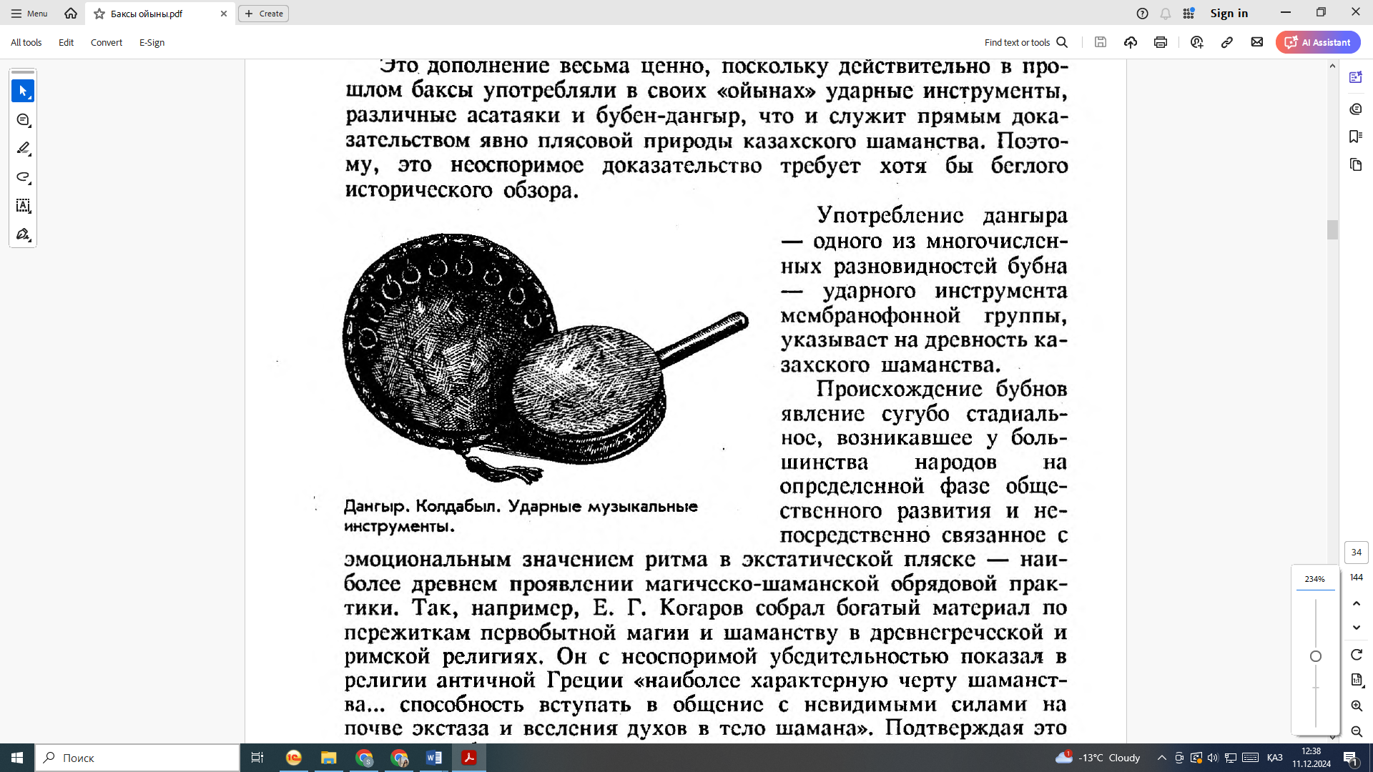

Fig. 1.Dangyr. Koldabyl.

Percussion Musical Instruments.Vsevolodskaya-Golushkevich O.V. (1996),

Baqsy oyny, 144. Rauan.

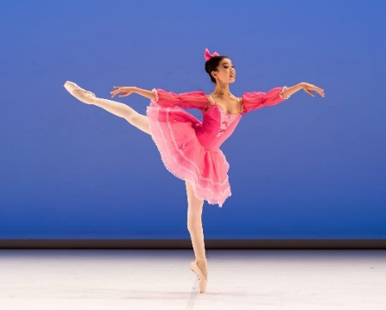

***Fig. 2. Zhanabil Ademi. Ballet "The Fairy of Dolls."****Kazakh National Academy of Choreography,*News*,*

[*https://balletacademy.edu.kz/ru/novost/pobeda-studentov-kazahskoj-nacionalnoj-akademii-horeografii-na-mezhdunarodnom-konkurse-budapest-ballet-grand-prix-v-vengrii*](https://balletacademy.edu.kz/ru/novost/pobeda-studentov-kazahskoj-nacionalnoj-akademii-horeografii-na-mezhdunarodnom-konkurse-budapest-ballet-grand-prix-v-vengrii)*,*

*accessed December 11, 2024.*

**Tables example**

|  |  |
| --- | --- |
|  |  |
|  |  |

***Source:*** *Anuar A.A. (2023).*

Choreographic Art of Kazakhstan*,*

*45. Nauka.*